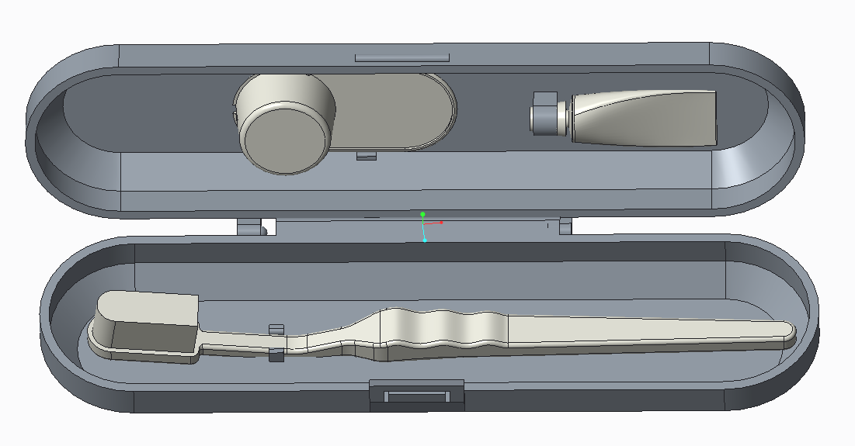



**User**

**MANUAL**

*ENGR 1202-M02*

**Team 13**

December 2017

**USER'S MANUAL**

**TABLE OF CONTENTS**

Page #

A. ASSEMBLY 1

1.1 Parts Assembly 1

B. USE AND MAITENANCE 2

2.1 Product Information 2

2.2 Instructions for Use 2

2.3 Maitenance 2

C. MAITENANCE AND RECOMMENDATIONS 3

3.1 Maitenance (continued) 3

3.3 Safety Recommendations 3

D. WARRANTY 4

4.1 Warranty Information 4

E. SERVICE CENTER 5

5.1 Information 5

5.2 Contacts 5

**1.0 Assembly**

## 1.1 Parts Assembly

This is a two-part assembly that requires a bottom and top half of the product. The item should snap together between two ball joints and a socket to ensure a secure connectivity.

* + - Locate bottom piece

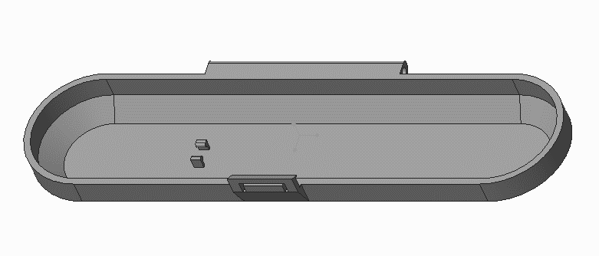

**Figure 1.** Bottom Piece

* + - Locate top piece

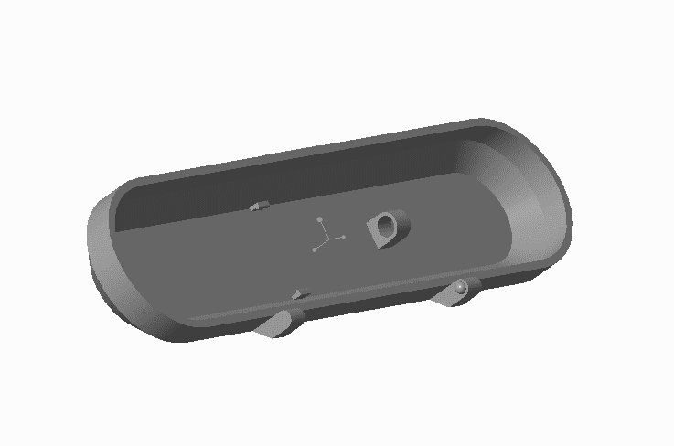

**Figure 2.** Top Piece

* + - Assemble both pieces together until the hinge snaps in place.

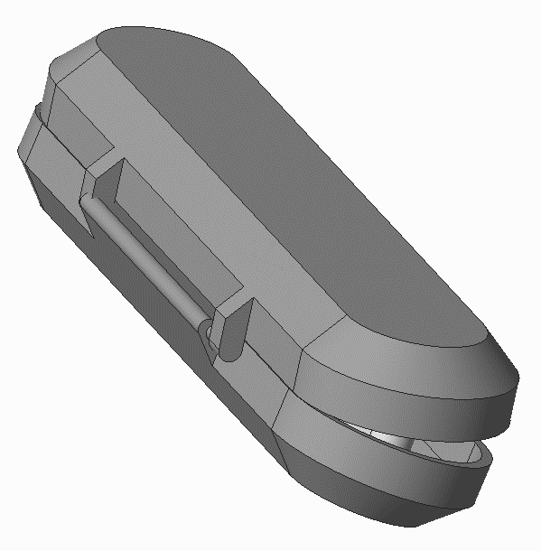

**Figure 3.** Combine Piece

**2.0 Use and Maintenance**

## 2.1 Product Information

Thank you for purchasing the travel pack. The Toothy pack was designed with all your oral hygiene needs in mind and allows you to conveniently carry all your oral hygiene necessities in a sealed case while traveling. The Toothy pack is the most compact oral hygiene travel case available. The unit is designed to accompany a toothbrush, travel size tube of toothpaste, and dental floss. It is designed to prevent from opening if it happens to tumble inside your luggage. Being waterproof inside and out avoids any remaining moisture from permeating through or leaking onto surrounding items or clothing. The Toothy packs unique hinge design makes it difficult to lose any pieces of the case. The Toothy pack also includes interior clips to secure all your belongings.

## 2.2 Instructions for Use

* 1. Remove the Toothy pack from the packaging.
  2. Remove oral hygiene necessities from the case.
  3. Wash the Toothy pack case with soap and warm water then allow to air dry.
  4. Assemble the two halves of the case using the provided hinge pins. *(Reference section 1.1 of the user manual for instructions on how to assemble this product)*
  5. Load oral hygiene necessities in the Toothy pack.

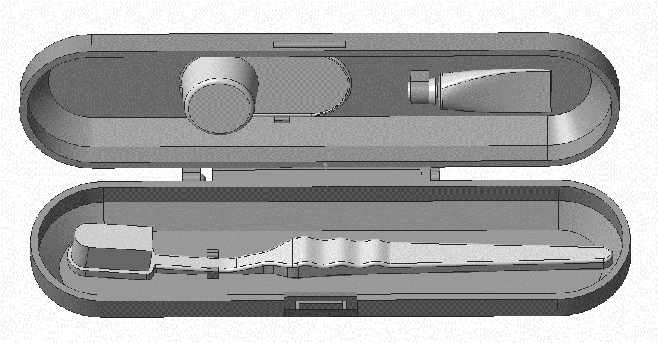

**Figure 4.** Inside Toothy

## 2.3 Maintenance

Toothy requires low maintenance, but it is recommended that the container be cleaned and disinfected once a week to ensure complete sanitization of the product. To do this, remove items from the container, properly wipe down with a cleaning cloth, and dry the product completely before further use.

**3.0 Maintenance Instructions and**

**Recommendations**

## 3.3 Maintenance (continued)

For proper maintenance, keep all oral hygiene products properly inside the box. Be sure to close it after every use to prevent any moisture from leaving or entering the box.

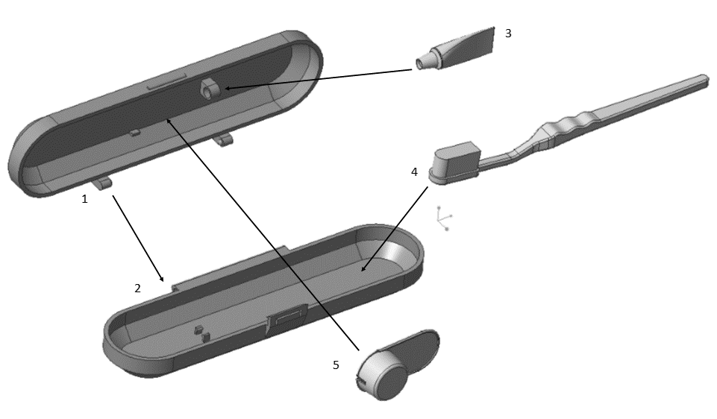

**Figure 5.** Exploded View

## 3.3 Safety Recommendations

The Toothy pack opens and closes using a hinge system. Please exercise caution when opening and closing to avoid self-injury.

To keep contents inside the travel pack clean and bacteria-free, wash the Toothy pack at least twice a week with soap and warm water. Please keep out of reach of pets or children as contents inside the Toothy pack may cause choking.

**4.0 Warranty Information**

## 4.0 Warrant Information

The Toothy pack has a 60-day limited warranty. If any pieces of the travel pack are damaged through normal use, please contact us so we may send you a new unit. We also offer a 30-day money back guarantee if you are not satisfied with our product, no questions asked.

1. **Service Center**

## 5.1 INFORMATION

If you have any questions regarding the Toothy pack or wish to make a return, please feel free to contact us.

Charlotte, NC distribution center hours of operation are 8:00 a.m. to 5:00 p.m. Monday-Friday

## 5.2 Contacts

Our product support team can be reached at any of the following emails:

Felix Vivongsy- [fvivongs@uncc.edu](mailto:fvivongs@uncc.edu)

Estefany Jimenez - [ejimene3@uncc.edu](mailto:ejimene3@uncc.edu)

Roa’A Al-Jabiri- [raljabir@uncc.edu](mailto:raljabir@uncc.edu)

Shane McManus- smcman10@uncc.edu

# 